Hospital Performance Analysis

Inpatient Rehabilitation Facility Quality Benchmarking: A CMS Care Compare Analysis
Business Context: Healthcare IT companies, payers, and provider networks require clear visibility into rehabilitation facility performance to support network adequacy decisions, value-based care contracting, referral routing, and competitive positioning. While CMS publishes this data, it is raw and measure-by-measure, making it difficult to translate into actionable provider-level intelligence.
Problem Statement: The CMS Inpatient Rehabilitation Facility (IRF) data is structured in a long format with inconsistent scoring types (numeric rates, confidence intervals, and categorical benchmarks). This project builds a reproducible ETL pipeline to transform raw CMS data into a provider-level quality scorecard and benchmarking dashboard.
Data Sources:
IRF Data Dictionary
Inpatient Rehabilitation Facility - Provider Data

Project Summary: Tools & Skills Matrix
Tools Utilized:
- Database & ETL: PostgreSQL, pgAdmin, Advanced SQL, Git Github, Microsoft VS code
- Data Validation: Microsoft Excel (upcoming :Pivot Tables, Data Modeling)
- Business Intelligence: Power BI (Upcoming: DAX, Interactive Dashboards)
- Programming & Automation: Python (Upcoming: Pandas, Scikit-Learn)
Core Skills Demonstrated:
- Data Engineering: ETL Processes, Database Design, DDL/DML, Data Profiling, Data Ingestion, Data Cleaning, Data Type Mapping
- Data Analytics & Modeling: Dimensional Modeling, Relational Mapping, Data Dictionary Creation, Advanced SQL (Window Functions, CTEs, Views), Pivoting, Statistical Analysis, Correlation Analysis, Composite Scoring
- Business Intelligence & Reporting: Benchmarking, Data Aggregation, Geographic Pattern Analysis, Data Quality Assessment, Data Suppression Techniques, Sensitivity Analysis, Visualizations, Stakeholder Reporting

Phase 1: Data Ingestion & ETL (Extract, Transform, Load)
I established a local relational database in PostgreSQL to ingest the raw CSV data. During the data ingestion phase, I performed a data profiling assessment, identifying that columns like CCN and ZIP codes contained leading zeros that required VARCHAR data types rather than integers. Furthermore, mixed-type fields (numeric scores, text benchmarks, and suppressed footnotes) were staged as TEXT to prevent import failures. Finally, I executed data cleaning by dropping redundant columns (address lines, phone numbers, footnotes, and date ranges) to optimize the dataset for downstream business intelligence analysis.

Phase 2: Dimensional Modeling & Measure Reference
Skills Demonstrated: Data Modeling, Relational Mapping, Data Dictionary Creation
To make the cryptic CMS measure codes readable for stakeholders, I engineered a measure_reference table to serve as a data dictionary. By mapping codes (e.g., I_006_01_SIR) to human-readable measure families (Pressure Ulcer, Falls, Readmissions) and defining the "direction of good" (higher vs. lower is better), I created a semantic layer. This step was critical for ensuring that the downstream data visualization and composite scoring accurately reflected clinical realities.

Phase 3: Core Analysis & Answering the Business Questions
1. Which IRFs perform best and worst on key quality measures?
I built the irf_facility_scorecard table, pivoting the long-format data so each row represents a unique facility (CCN) with side-by-side performance metrics. By leveraging the benchmark labels (Better, No Different, Worse) as the primary statistical signal rather than just raw numeric scores, I isolated statistical significance. This allowed me to generate precise top 10 and bottom 10 lists for Pressure Ulcers and Falls, proving that a minority of facilities significantly outperform the national baseline.
2. How does facility quality vary by state and CMS region, and are there geographic patterns?
I created aggregated views (irf_state_quality and irf_region_quality) to analyze geographic patterns. By calculating the percentage of facilities outperforming the benchmark per state, I identified regional clusters. The analysis revealed that while no region is uniformly excellent, specific states demonstrate higher concentrations of below-benchmark performance on readmissions (e.g., WV, NV, FL). I also applied data suppression techniques (filtering out states with fewer than 5 facilities) to ensure statistical validity.
3. Do facilities that perform well on one measure also perform well on others?
To test the hypothesis of whether quality is general or measure-specific, I built a co-performance matrix and utilized CORR() functions. The results demonstrated that quality is highly measure-specific. Facilities that excel in discharge-to-community do not necessarily excel in readmissions. This correlation analysis proved that a single "quality score" cannot substitute for granular, measure-level evaluation in referral decisions.
4. Which facilities have missing or suppressed data, and how does it affect benchmarking?
I analyzed data quality by quantifying Not Available scores and footnotes. The analysis revealed that suppression is systematically concentrated in low-volume and specialty facilities. By comparing average eligible case volumes between reporting and suppressed groups, I proved that missing data biases national and state averages toward larger, established facilities. This data quality assessment highlighted the critical need to explicitly state reporting denominators in all visualizations to avoid misleading stakeholders.
5. Can we build a composite quality indicator to support referral or network decisions?
I engineered a transparent composite index (irf_composite_index), converting benchmark categories into a +1 / 0 / -1 scale. A sensitivity analysis revealed that rankings shift significantly under different weighting schemes, and the final coverage statement showed that only 21.3% (260 out of 1,222) of facilities are fully benchmarkable across all four measures. Therefore, the composite index serves only as a screening tool for shortlisting, while final network decisions must rely on the measure-level scorecard.

Final Conclusion & Next Steps
This PostgreSQL phase successfully transformed raw, messy CMS data into a validated, queryable asset. By combining advanced SQL techniques with clinical domain knowledge, I demonstrated that while CMS data is highly actionable for measure-specific benchmarking, it cannot support a single composite ranking due to measure-specificity and systematic data suppression.
Future Phases: I will export these structured views into Microsoft Excel for pivot table validation and Power BI to build an interactive, stakeholder-facing dashboard (incorporating DAX and dynamic filtering). Finally, I will utilize Python (Pandas/Scikit-Learn) to automate the ETL pipeline and perform predictive modeling on facility performance trends.

Down Below i have included the steps i took to create through answering the core questions and how i navigated through engineering this project along with visuals and table results from the queries:

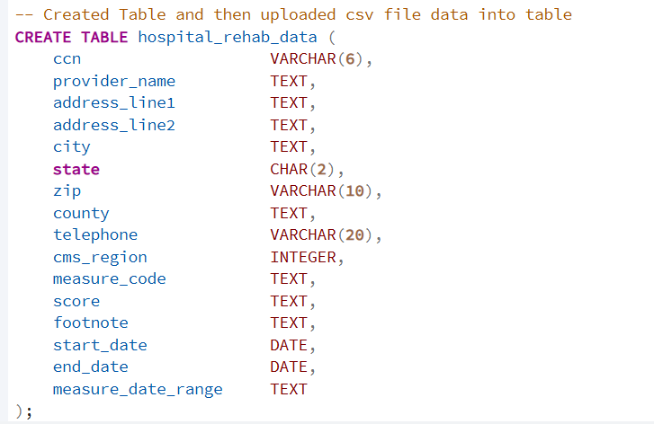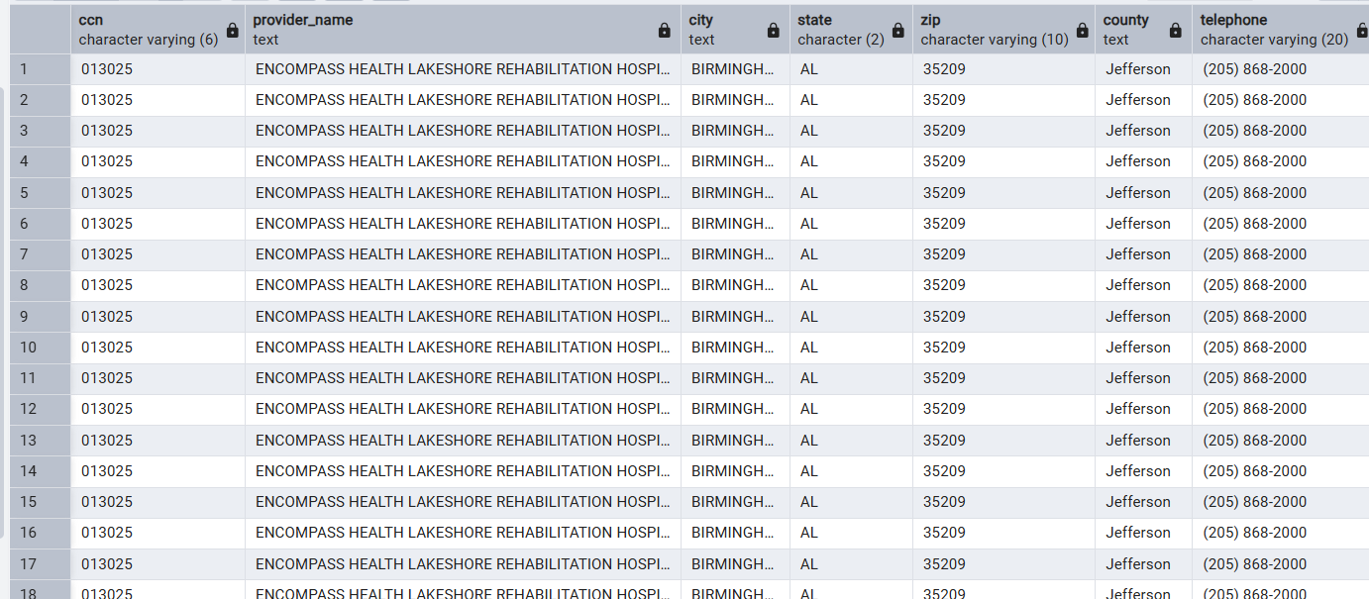
After the table was created and checked to see if the data has been properly loaded onto the table with the SELECT * statement, i cleaned the data up to get rid of unnecessary information such as phone number, address line 1 and 2, footnote, and date range. None of the following data was needed for my final outcome and project to answer the big data problem companies are needing to be answered. 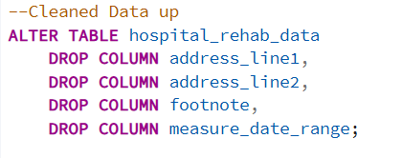
After cleaning up the table, checking to see how it looks and making sure all the necessary data needed has been properly loaded, I proceeded to critically think and problem solve the following core questions for my next phase in this project.
Core questions:
- Which IRFs perform best and worst on key quality measures (e.g., pressure ulcers, falls with major injury, functional outcomes, readmissions)?
- How does facility quality vary by state and CMS region, and are there geographic patterns?
- Do facilities that perform well on one measure also perform well on others, or is quality highly measure-specific?
- Which facilities have missing or suppressed data (footnoted results), and how does that data quality issue affect the ability to benchmark?
- Can we build a composite quality indicator to support referral or network decisions?

Answering the question for : Which IRFs perform best and worst on key quality measures (e.g., pressure ulcers, falls with major injury, functional outcomes, readmissions)?
My thought process on this question came to thinking on which facilities have the measures for the best and the worst, i then created tables to showcase this data and with the select statements to be able to view and filter those created tables by the information which is needed and to clean up the results filtering them down to get a general view on the needed data.
Here below I'm attaching copies of the screenshot by the tables I created with the filtered table data to answer the question.
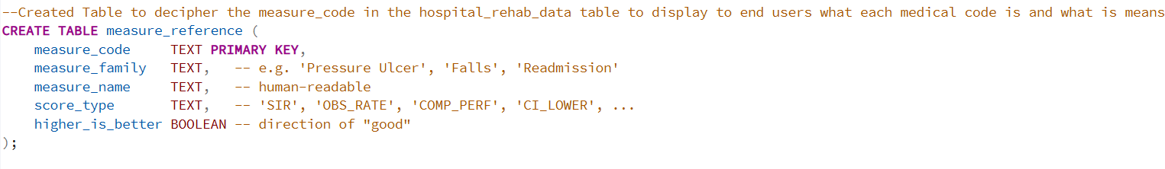
After creating the table to showcase the appropriate data linked to answering the question, I then inserted the following values into the table to distinguish and show in layman's terms for a readable outcome measure for users to understand what each of the codes are in the table data. 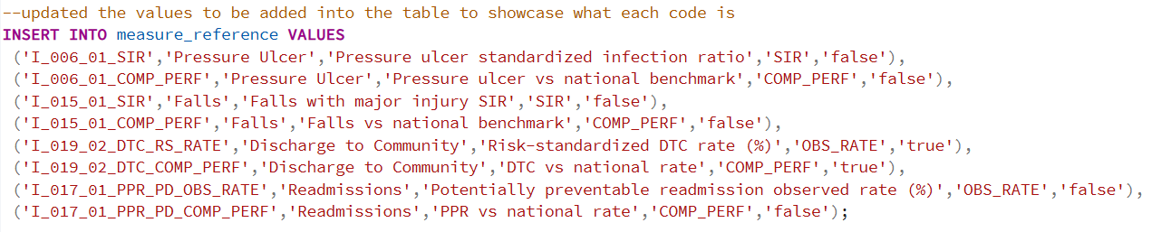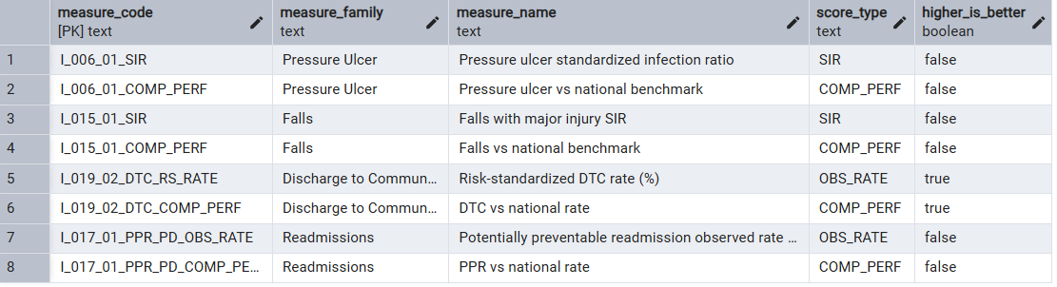
I need to answer the following question for #2:I then wanted to create another table to view the data by the newly created values i inserted upon the table to filter down such extensive data filtered and grouped by the ccn info. 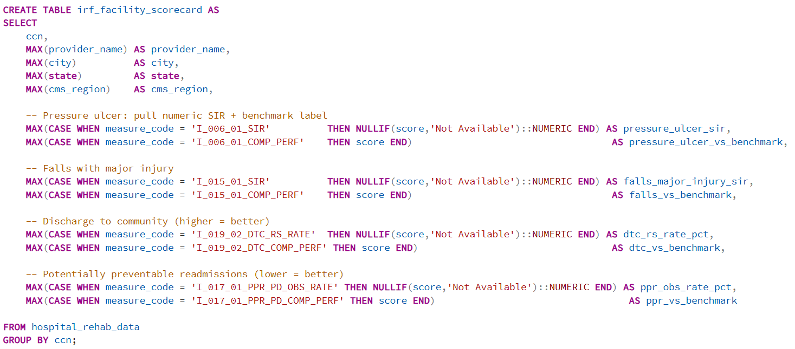The following is to view a sample of the table data 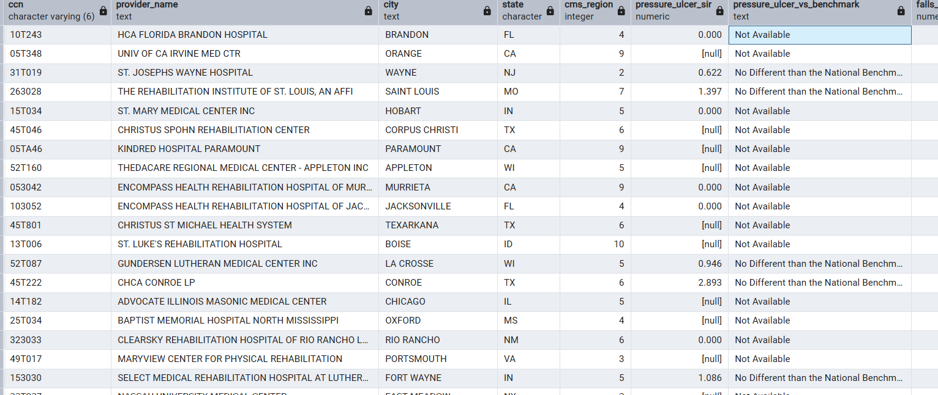
I took the table and proceeded to initialize and view the table filtered down with answering the following information users need to view for the final outcome of answering the question in this section: BEST (lowest SIR) — statistically better performers and WORST (highest SIR) — statistically worse performers. The following information will be showcased in my outcome of the project 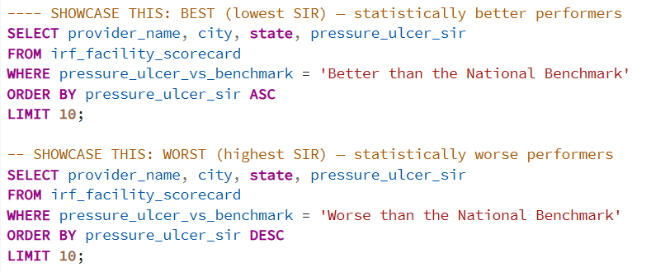
BEST (lowest SIR) — statistically better performers data raw view:(Proud that one of the top performers are from Jacksonville FL that is my hometown and where iv’e also had experience as a clinician in the healthcare field)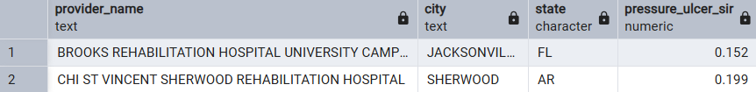
WORST (highest SIR) — statistically worse performers data raw table view: 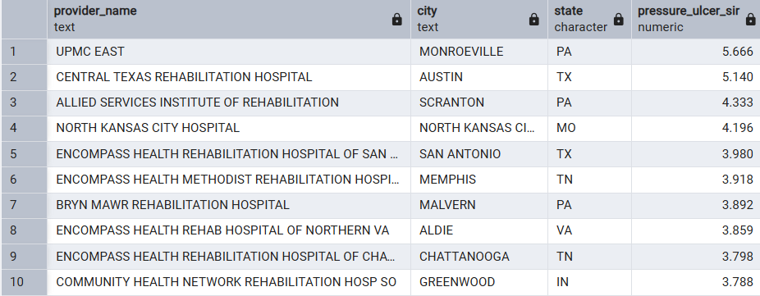
I dived deeper into answering the full question regarding the geographical patterns by the irf_state_quility table as a select statement to view the data by geographical patterns answering the following : How does facility quality vary by state and CMS region, and are there geographic patterns?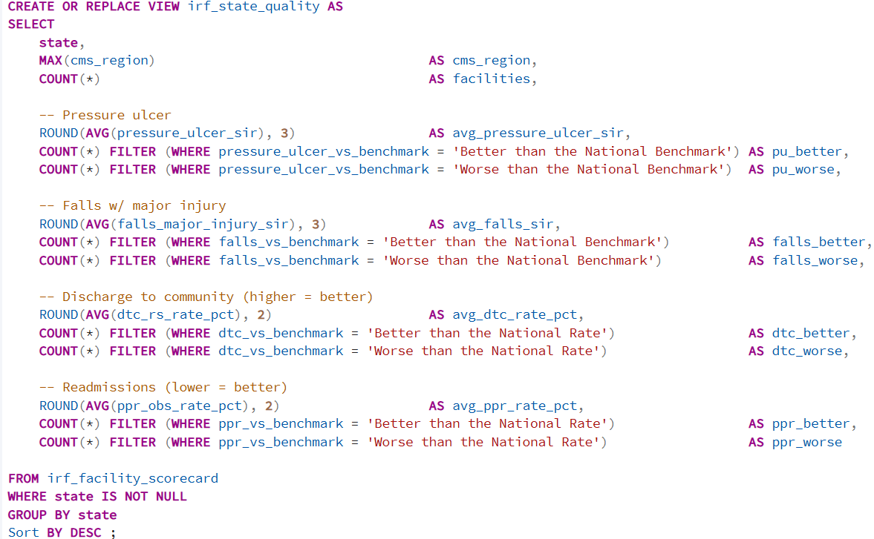Here is the viewable sample table data 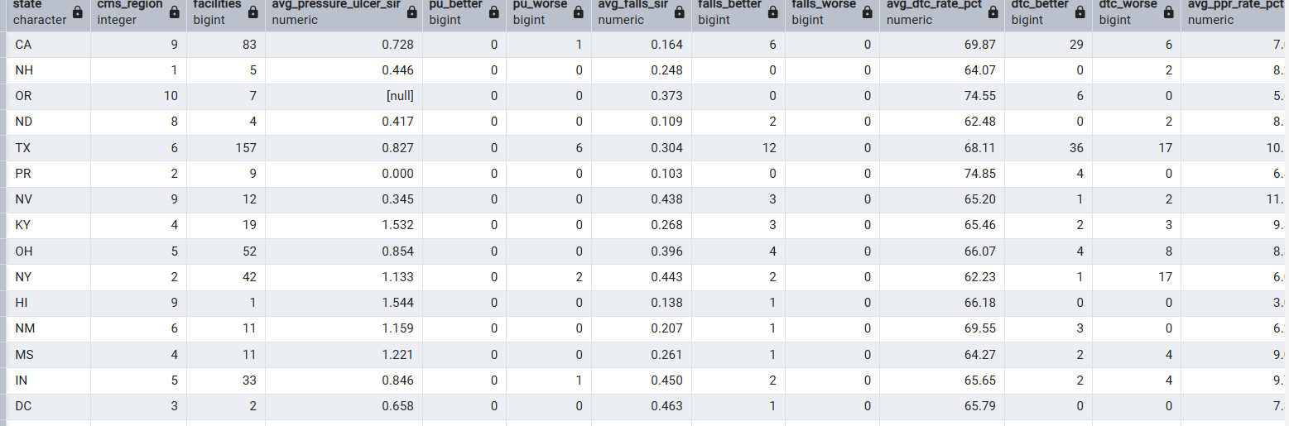
I then implemented another table to a parallel view rolled up to the 10 CMS regions: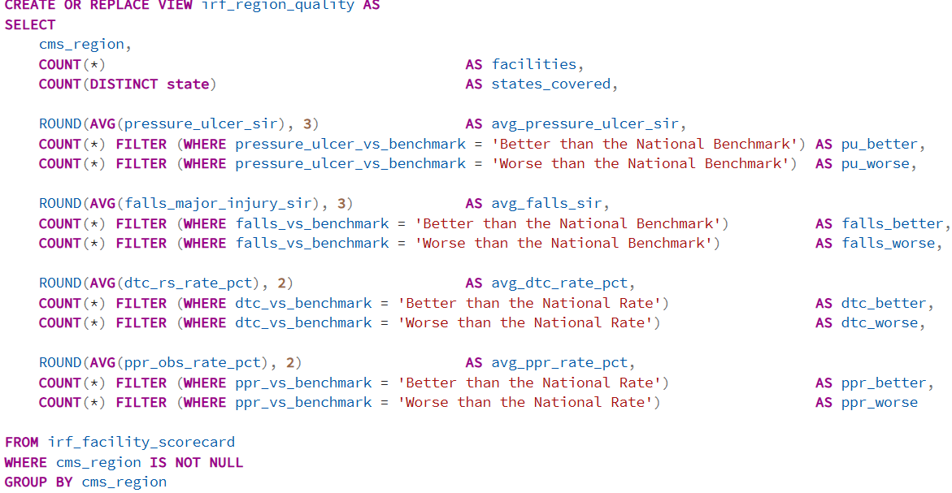
Circled back into diving even deeper to answer question # 2 i need to be able to view directly which exact states have optimal discharge performances ordering by descending values and limiting 10 to view top information and filtering down the redundant table data and also the be able to view the highest re-admissions by state. 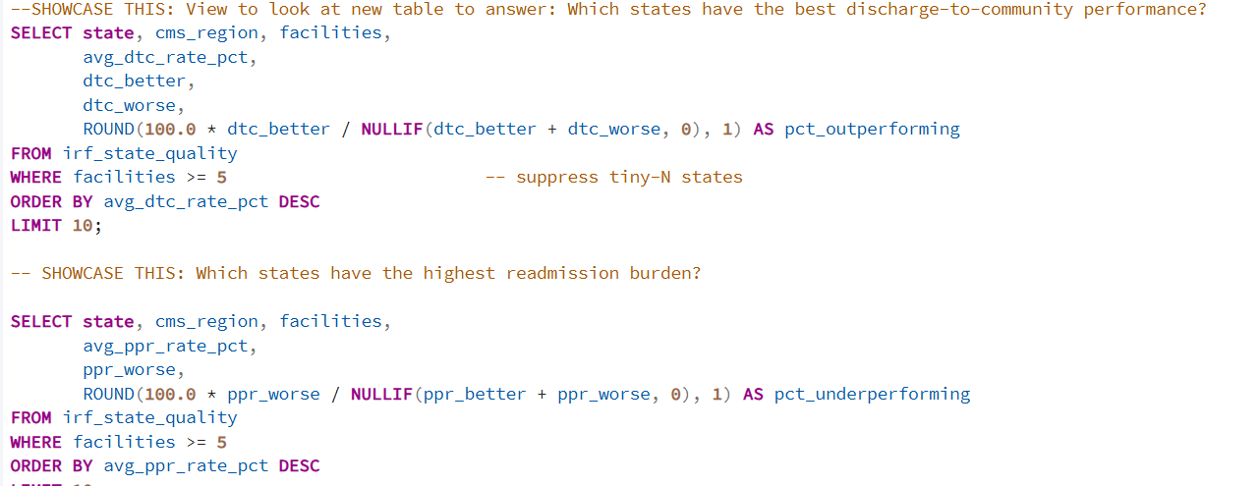Here is the following view of the best discharges for the table data answering :Which states have the best discharge-to-community performance? The three top performers are PR, OR and AZ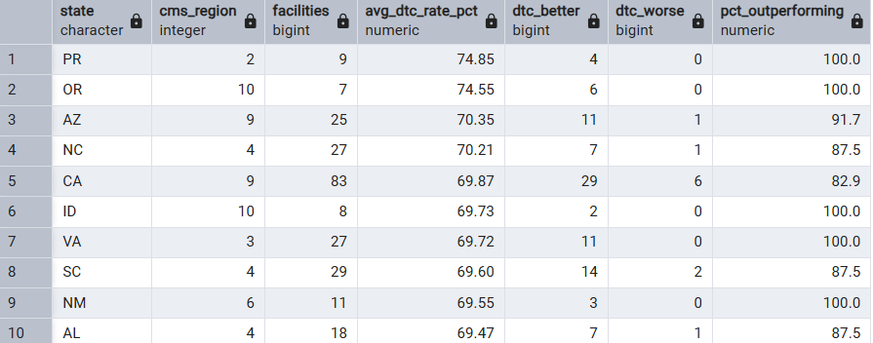This is the raw table data for Which states have the highest readmission burden?- it looks like the top three states with the worst outcome measures are WV, NV, and FL. 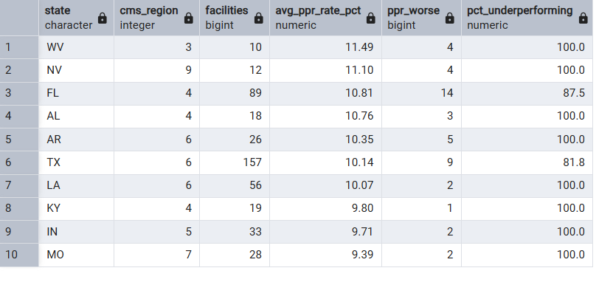Now I answered this question to dive deeper into the final results: Are there geographic patterns? A single "hotspot" query, which states are simultaneously worse-than-benchmark on readmissions AND pressure ulcers? Below is the raw SQL code and Table data results from the following selection and filtered down information.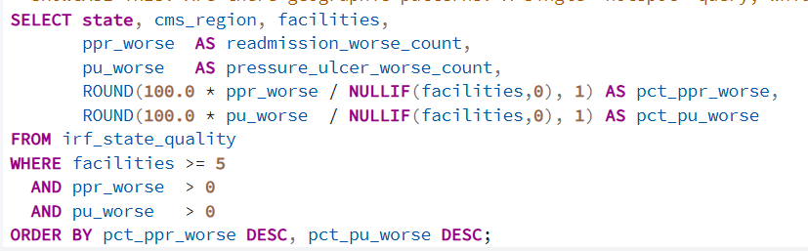Here is the Table view of the code showcasing to answer the question.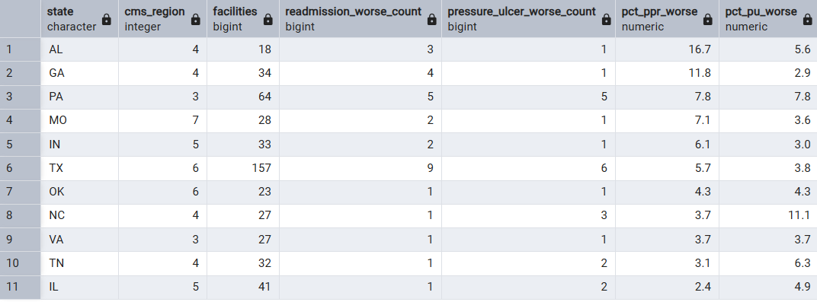This data down below displays the regional comparison table data measures. 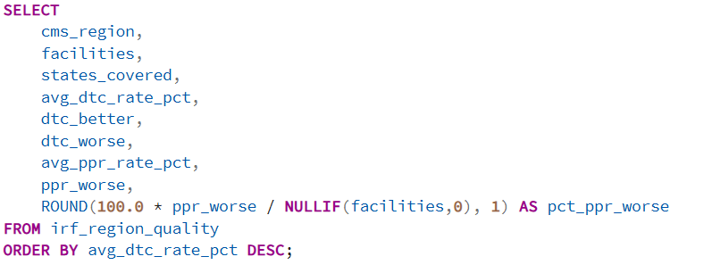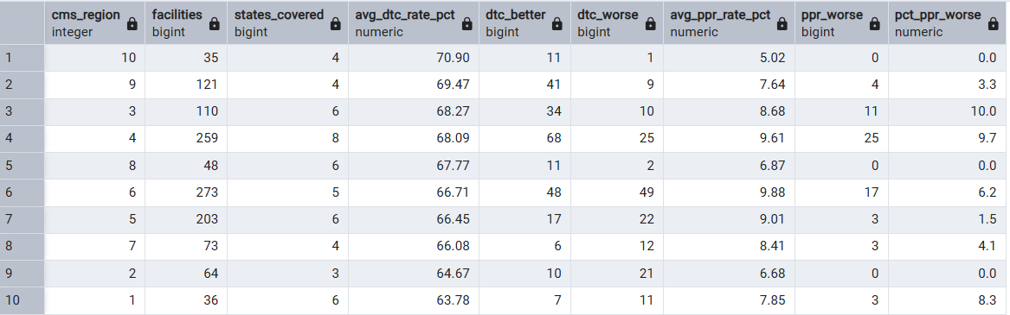Answering core question number 3.)Do facilities that perform well on one measure also perform well on others, or is quality highly measure-specific?- i narrowed down the information by some table data management incorporating critical thinking measures by building a co performance matrix view: diving deeper into it by the following question : how many facilities were better-than-benchmark on both, worse on both, and the mixed cases? Here is the following raw SQL code to showcase answering this info.

CREATE OR REPLACE VIEW irf_measure_coperformance AS
WITH b AS (
SELECT
ccn,
(pressure_ulcer_vs_benchmark = 'Better than the National Benchmark')::INT AS pu_better,
(pressure_ulcer_vs_benchmark = 'Worse than the National Benchmark')::INT AS pu_worse,
(falls_vs_benchmark = 'Better than the National Benchmark')::INT AS falls_better,
(falls_vs_benchmark = 'Worse than the National Benchmark')::INT AS falls_worse,
(dtc_vs_benchmark = 'Better than the National Rate')::INT AS dtc_better,
(dtc_vs_benchmark = 'Worse than the National Rate')::INT AS dtc_worse,
(ppr_vs_benchmark = 'Better than the National Rate')::INT AS ppr_better,
(ppr_vs_benchmark = 'Worse than the National Rate')::INT AS ppr_worse
FROM irf_facility_scorecard
)
SELECT 'Pressure Ulcer x Falls' AS measure_pair,
SUM(pu_better * falls_better) AS both_better,
SUM(pu_worse * falls_worse) AS both_worse,
SUM(pu_better * falls_worse) + SUM(pu_worse * falls_better) AS mixed,
SUM(GREATEST(pu_better, pu_worse) * GREATEST(falls_better, falls_worse)) AS evaluable
FROM b
UNION ALL
SELECT 'Pressure Ulcer x Readmission',
SUM(pu_better * ppr_better), SUM(pu_worse * ppr_worse),
SUM(pu_better * ppr_worse) + SUM(pu_worse * ppr_better),
SUM(GREATEST(pu_better, pu_worse) * GREATEST(ppr_better, ppr_worse))
FROM b
UNION ALL
SELECT 'Falls x Readmission',
SUM(falls_better * ppr_better), SUM(falls_worse * ppr_worse),
SUM(falls_better * ppr_worse) + SUM(falls_worse * ppr_better),
SUM(GREATEST(falls_better, falls_worse) * GREATEST(ppr_better, ppr_worse))
FROM b
UNION ALL
SELECT 'Discharge to Community x Readmission',
SUM(dtc_better * ppr_better), SUM(dtc_worse * ppr_worse),
SUM(dtc_better * ppr_worse) + SUM(dtc_worse * ppr_better),
SUM(GREATEST(dtc_better, dtc_worse) * GREATEST(ppr_better, ppr_worse))
FROM b
UNION ALL
SELECT 'Pressure Ulcer x Discharge to Community',
SUM(pu_better * dtc_better), SUM(pu_worse * dtc_worse),
SUM(pu_better * dtc_worse) + SUM(pu_worse * dtc_better),
SUM(GREATEST(pu_better, pu_worse) * GREATEST(dtc_better, dtc_worse))
FROM b
UNION ALL
SELECT 'Falls x Discharge to Community',
SUM(falls_better * dtc_better), SUM(falls_worse * dtc_worse),
SUM(falls_better * dtc_worse) + SUM(falls_worse * dtc_better),
SUM(GREATEST(falls_better, falls_worse) * GREATEST(dtc_better, dtc_worse))
FROM b;

Breaking this down even further with another select statement for quality is measure-specific — performance on one measure tells you little about another. Here is the table data and SQL results to narrow this down. 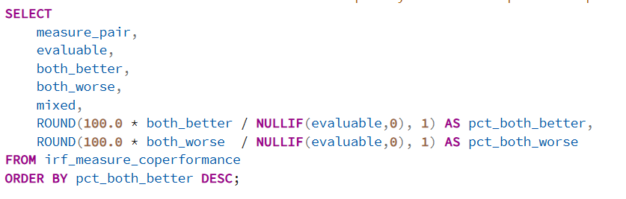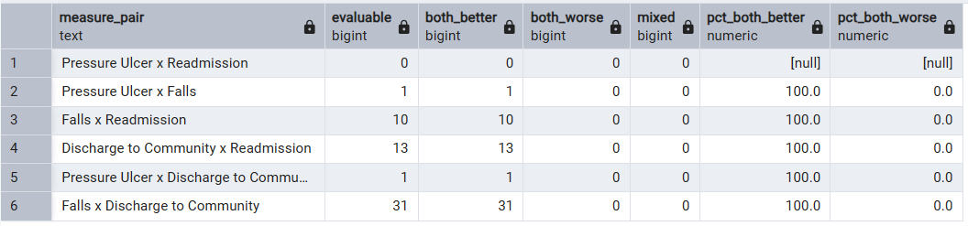
Going to the question for #4 Which facilities have missing or suppressed data (footnoted results), and how does that data quality issue affect the ability to benchmark? In order to properly answer this question i broke down to being able to view the table data for suppression rate per measure family.CMS publishes each facility's score against a national benchmark. The goal is to identify which facilities are statistically better or worse — not just numerically higher or lower — on pressure ulcers, falls with major injury, discharge to community, and readmissions.

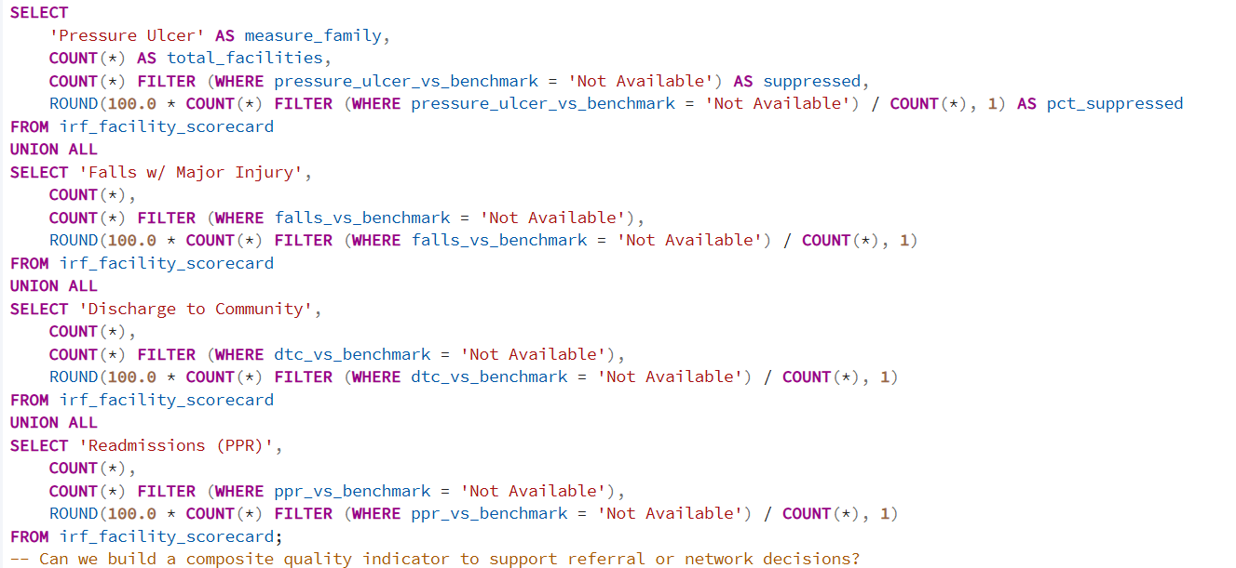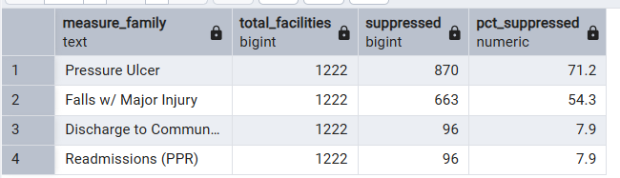

Here is to another filtered table view for a list of suppressed facilities … And what is means : The numeric scores (SIR, rates) tell you how far a facility is from the national baseline. The benchmark label (Better, No Different, Worse, Not Available) is CMS's own statistical significance test — it tells you whether that difference is real or just noise. The benchmark label is the primary signal; the numeric score is the tiebreaker and ordering tool. 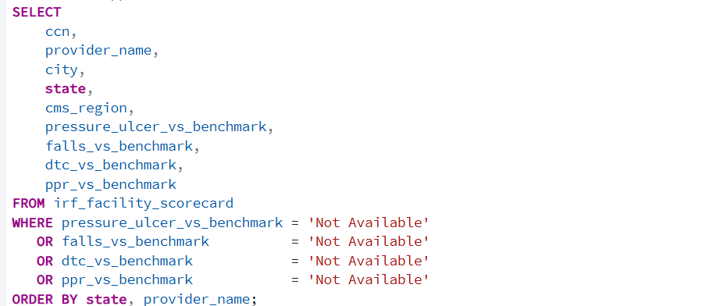Table vew: 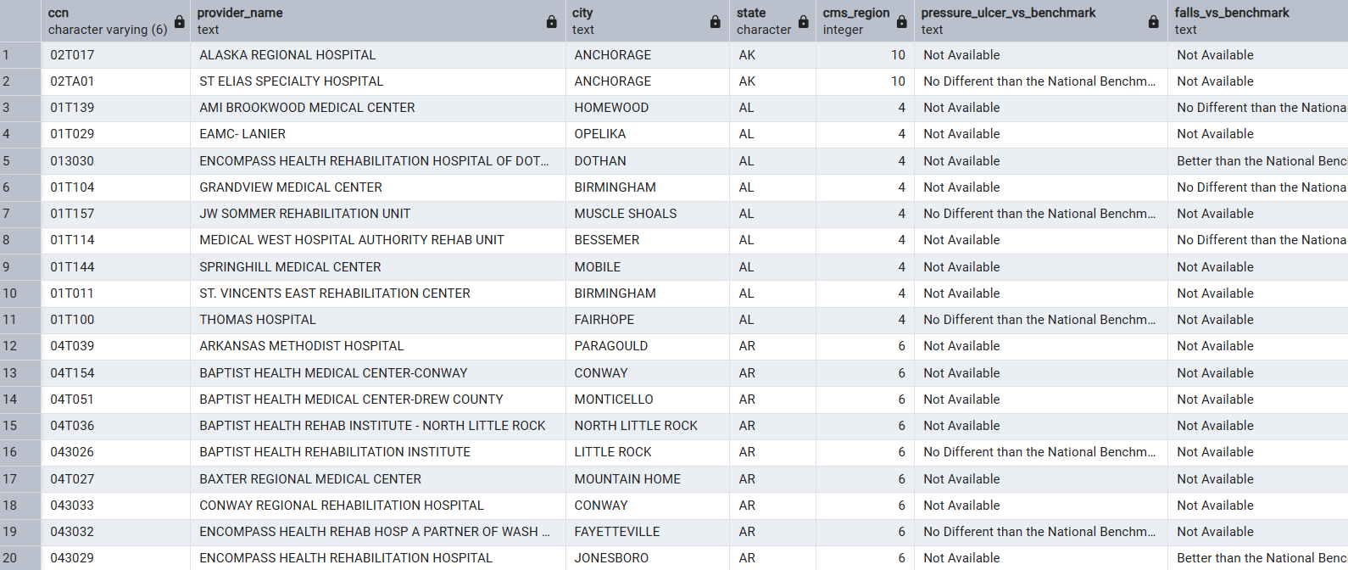Now i need to be able to view if suppressed facilities differ from the actual reporting ones which results will prove bias claims. Compares facility size proxies (eligible cases / denominator volume) between suppressed and reporting groups.
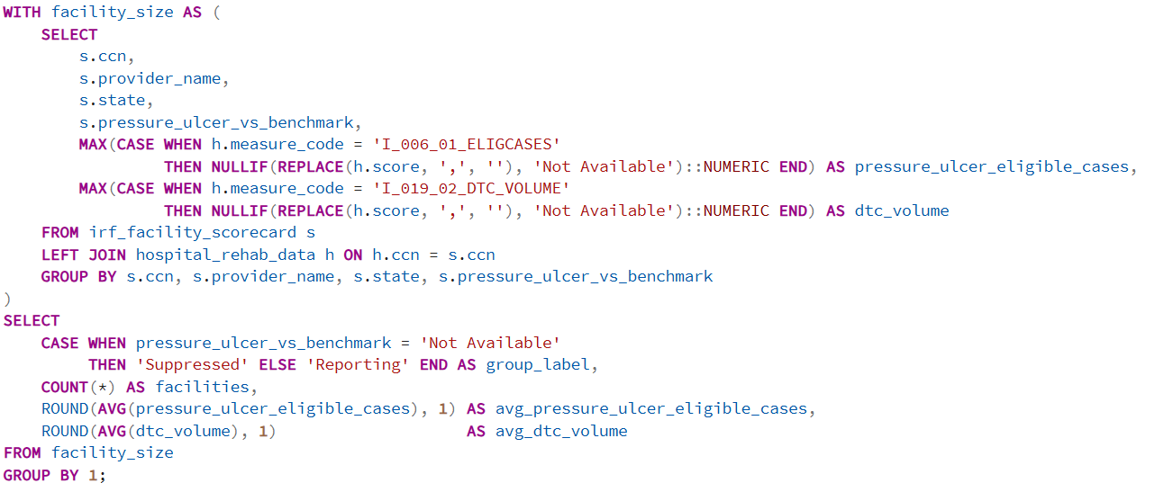Table results to view the suppressed data which shows about 870 facilities are suppressing the data.
A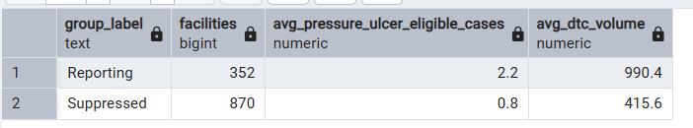To answer the final core question: Can we build a composite quality indicator to support referral or network decisions? I need to engineer a table showcasing the necessary data needed to support the index tables, showcase that table being ranked and filtered down, and make a query to prove the facilities with positive and negative measures. Here below is the created table information and query results. 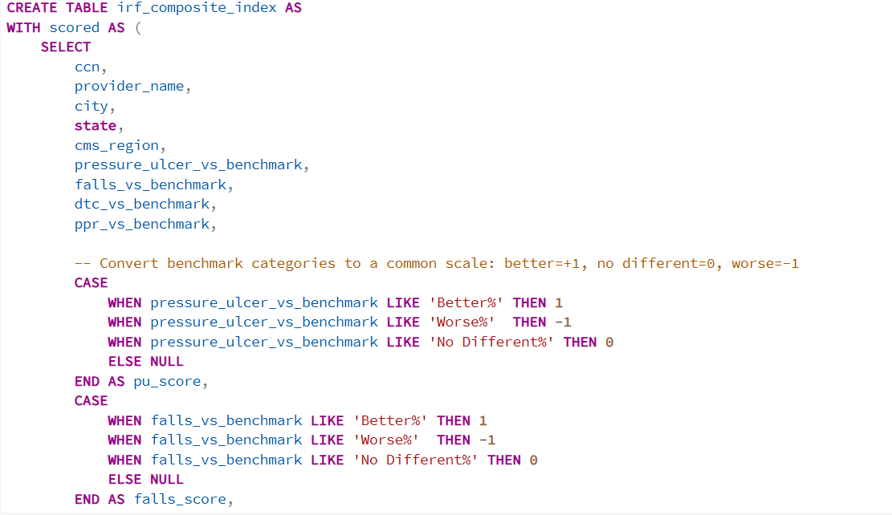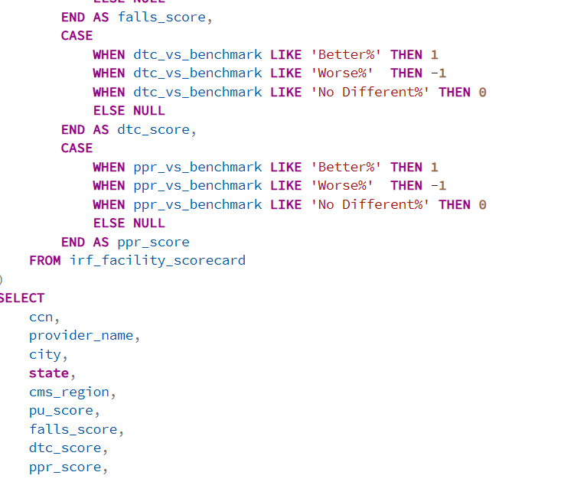Here I have the fileted SQL results of the count for the full and partial benchmark data.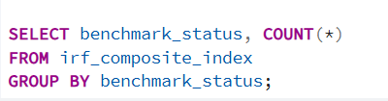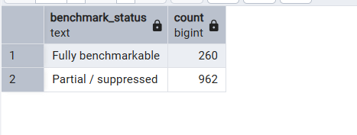The selected results for the best Performers 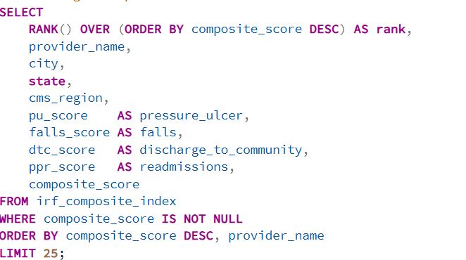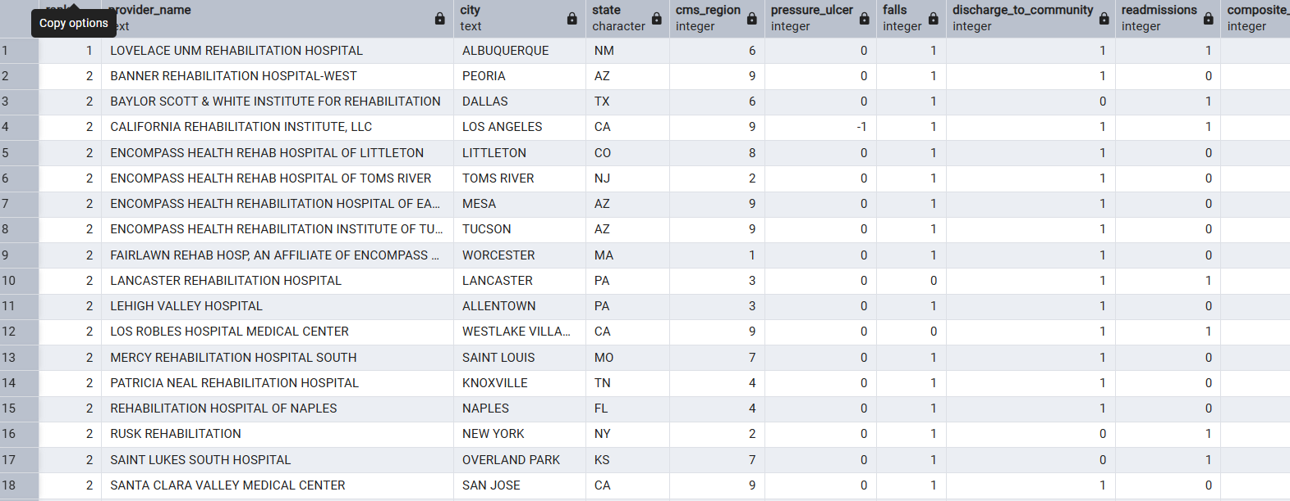Ans the worst Performers: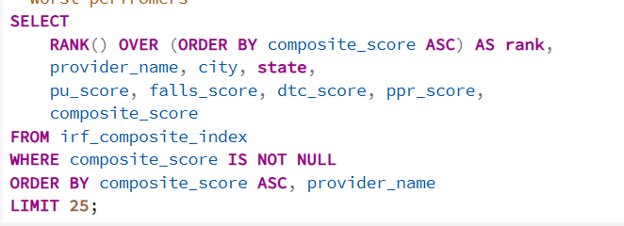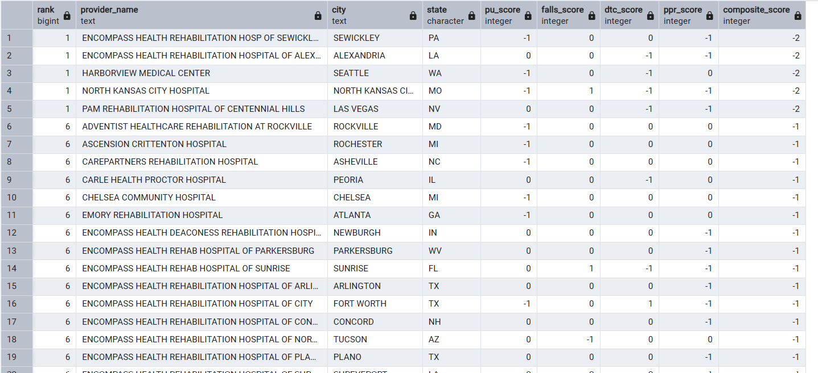Added a select final coverage statement to display results of count of total facilities that are suppressed and fully benchmarked and a final percentage of 21.3% that are fully benchmarked. 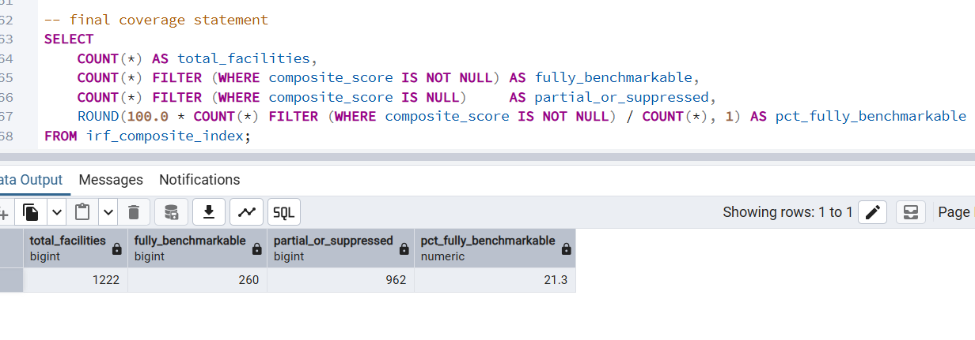The composite index is a transparent, auditable screening tool for referral and network shortlisting. Sensitivity analysis shows rankings shift under reasonable weight changes, and only Z% of facilities are fully benchmarkable, so the composite is a prioritization aid — final referral and network decisions must use the measure-level scorecard.

